- Though monthly UK GDP data suggest the upturn may be faltering, recent outturns have been very noisy at a sectoral level, and we think the economy continues to carry solid momentum. So we have maintained our forecast that GDP will grow by 1.1% this year and 1.7% in 2025.
- Data issues were also to the fore in this week's labour market release. The Labour Force Survey remains beset by volatility and the chunky fall in unemployment is unlikely to be a true reflection of underlying trends. Other series suggest that labour market conditions are continuing to gradually loosen.
Noisy data made it harder than usual to parse the key messages from this week's two major releases. On balance, we remain confident that the economy is still carrying decent momentum. But despite solid activity growth, labour market conditions are continuing to steadily loosen.
After a series of strong outturns in the early months of 2024, GDP was flat for a second successive month in July. At the sector level, there was a series of large offsetting swings. As expected, the drags in June from a sharp fall in retail sales and the impact of industrial action on the health sector unwound in July. But these boosts to activity in July were offset by falls in manufacturing, construction, and professional services output (Chart 1).
Nevertheless, in each case, July's declines in output appeared to be payback for very strong outturns in June. Business survey data continues to flag a solid pace of activity growth. And the momentum that the economy carried into this quarter should mean that GDP still grows by 0.3%-0.4% quarter-on-quarter in Q3. Though this would be some way below the rates achieved in H1, the Q1 and Q2 rates were well above trend pace. Furthermore, as we argued in a recent note, the consumer has played only a small role in the upturn so far. But with confidence improving and real income growth remaining solid, there's good reason to expect a more meaningful pickup in consumer spending going forwards. So we have maintained our forecast that GDP will grow by 1.1% this year and 1.7% in 2025.
Chart 1: A series of large, offsetting, swings in sector output left GDP flat in July
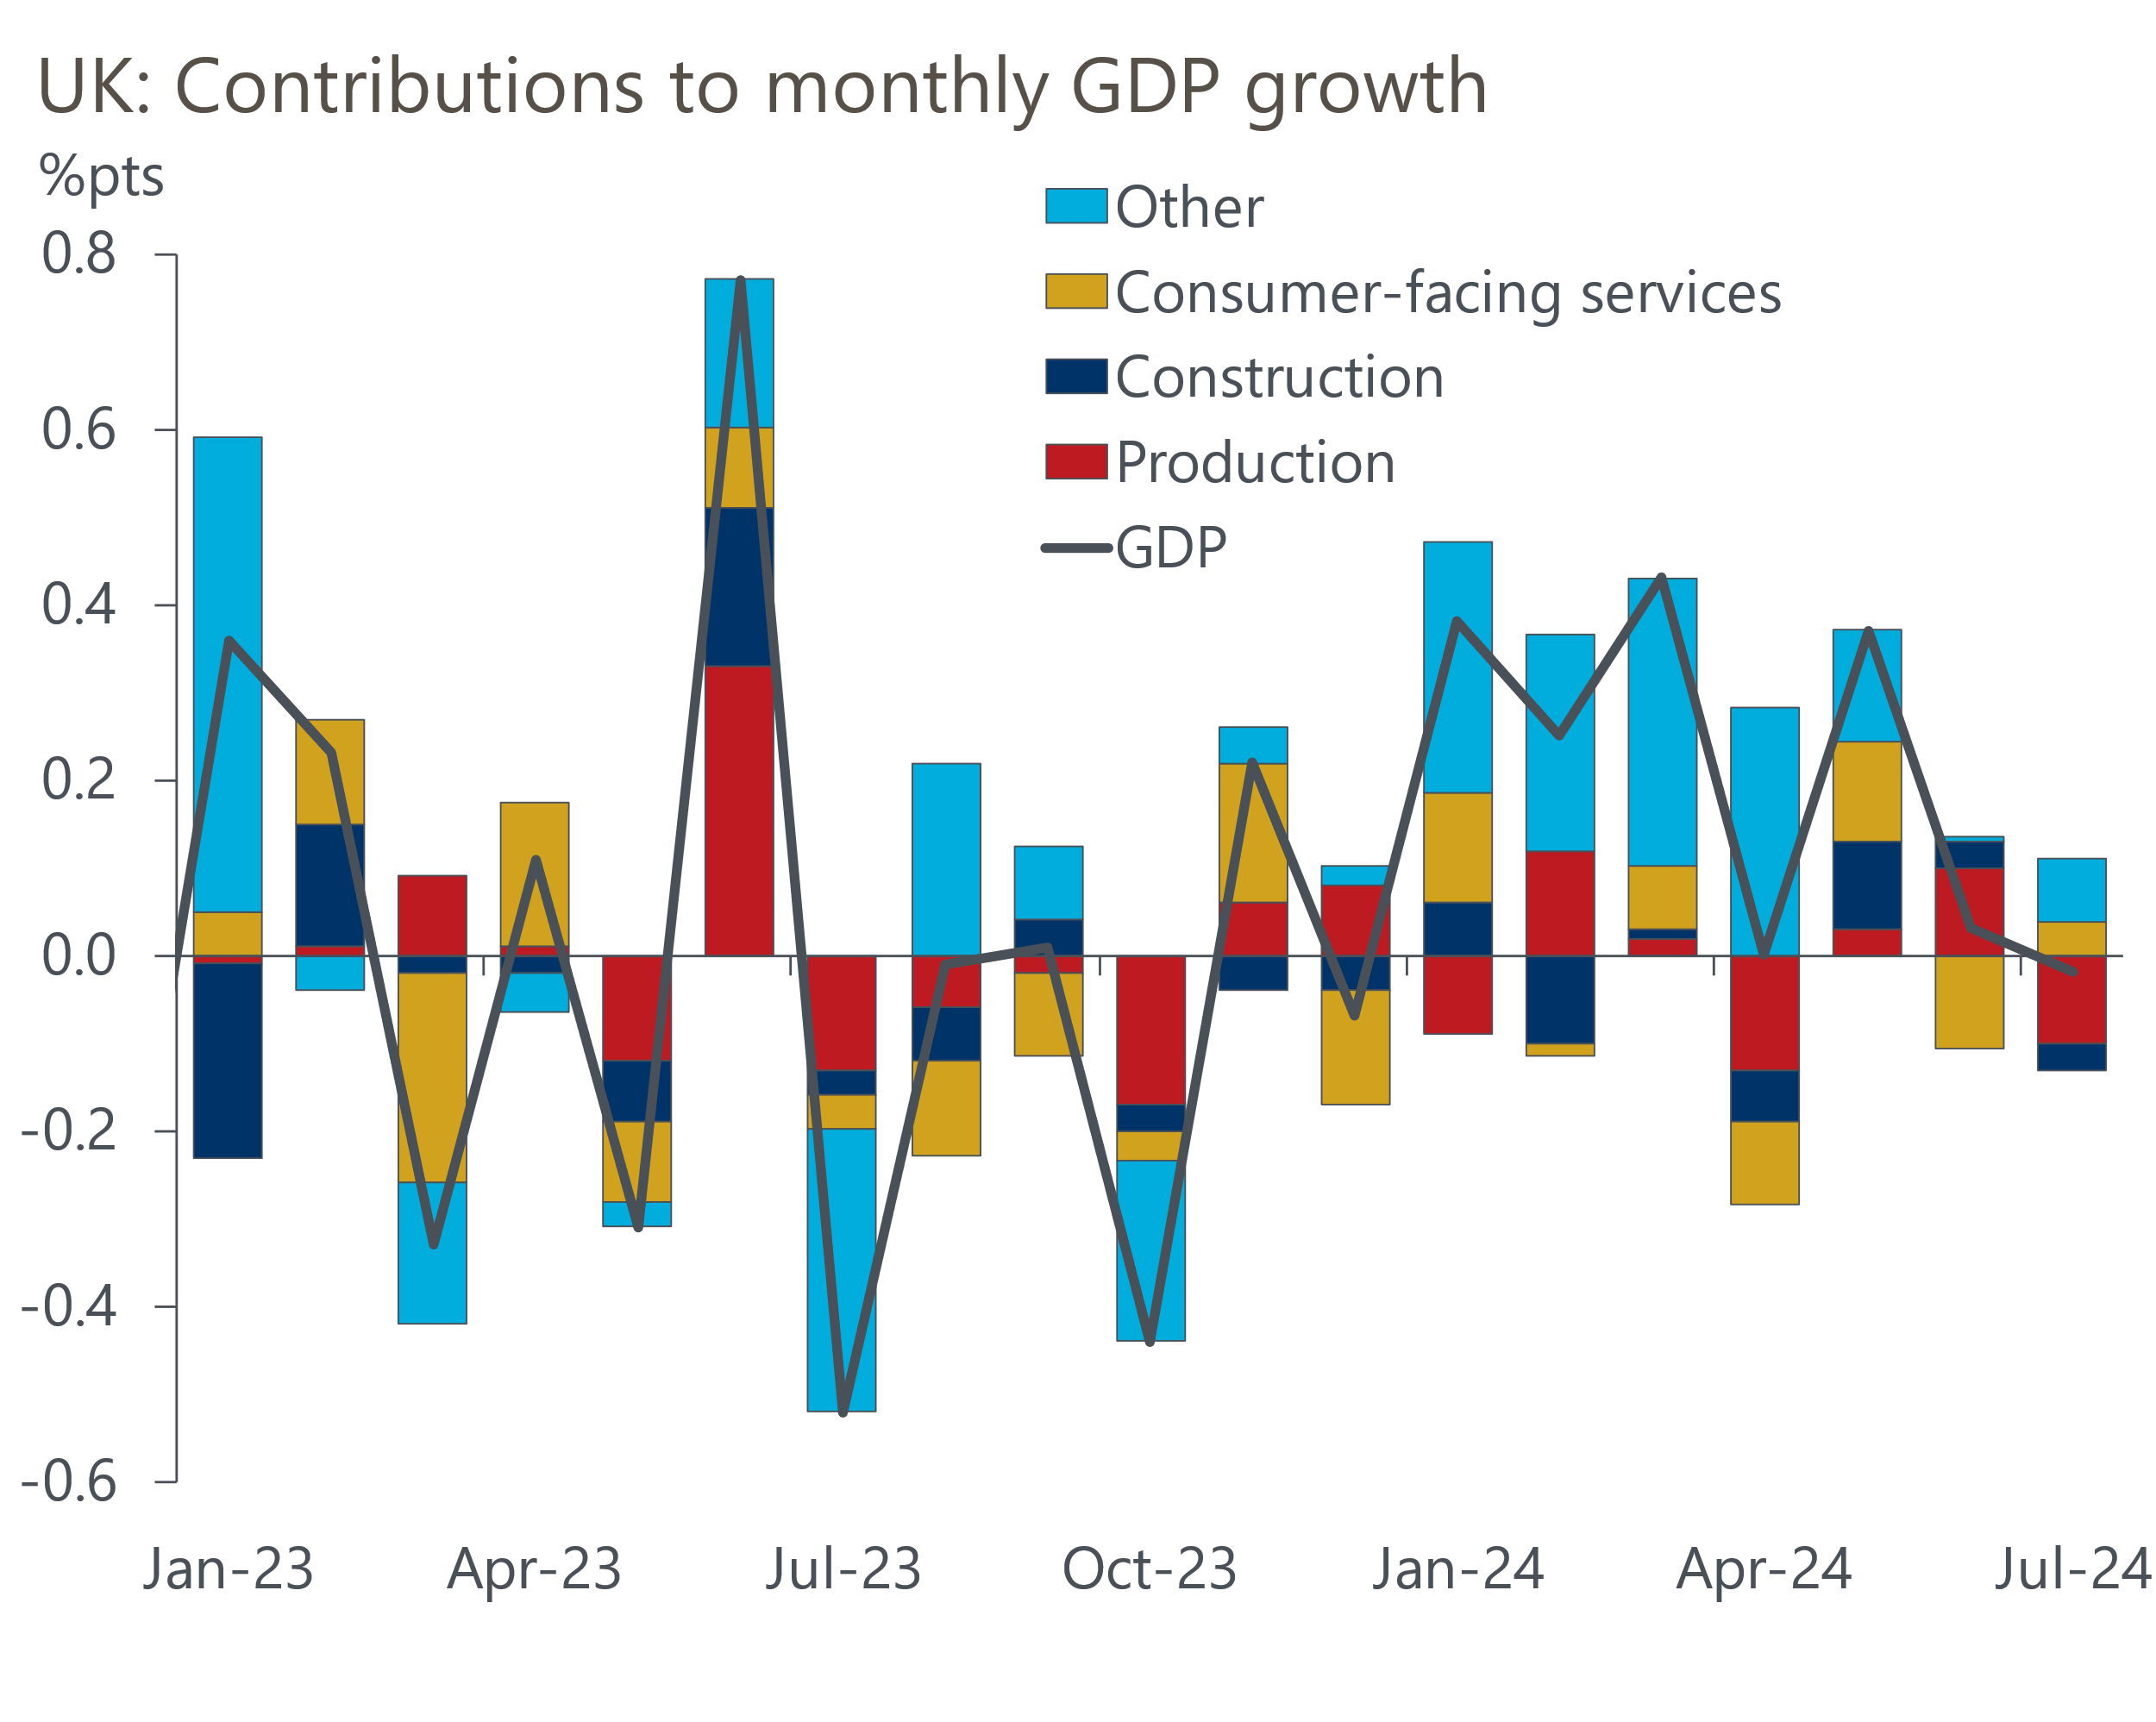
Source: Haver Analytics

On the face of it, this week's labour market release suggested that this year's pickup in activity has resulted in unemployment dropping sharply. The Labour Force Survey reported an unemployment rate of 4.1% in the three months to July, down 0.3ppts on the previous quarter. But the single-month estimates that underpin the three-month average demonstrate the scale of the volatility problem that the Office for National Statistics is struggling to get on top of, with the three estimates ranging from 3.7% to 4.4%. Indeed, as Chart 2 shows, over the past couple of years, the single month observations resemble a collection of random dots with no obvious trend or pattern. So it's clear that this data offers little insight into what's currently happening in the labour market.
Chart 2: Labour Force Survey data remains beset by volatility
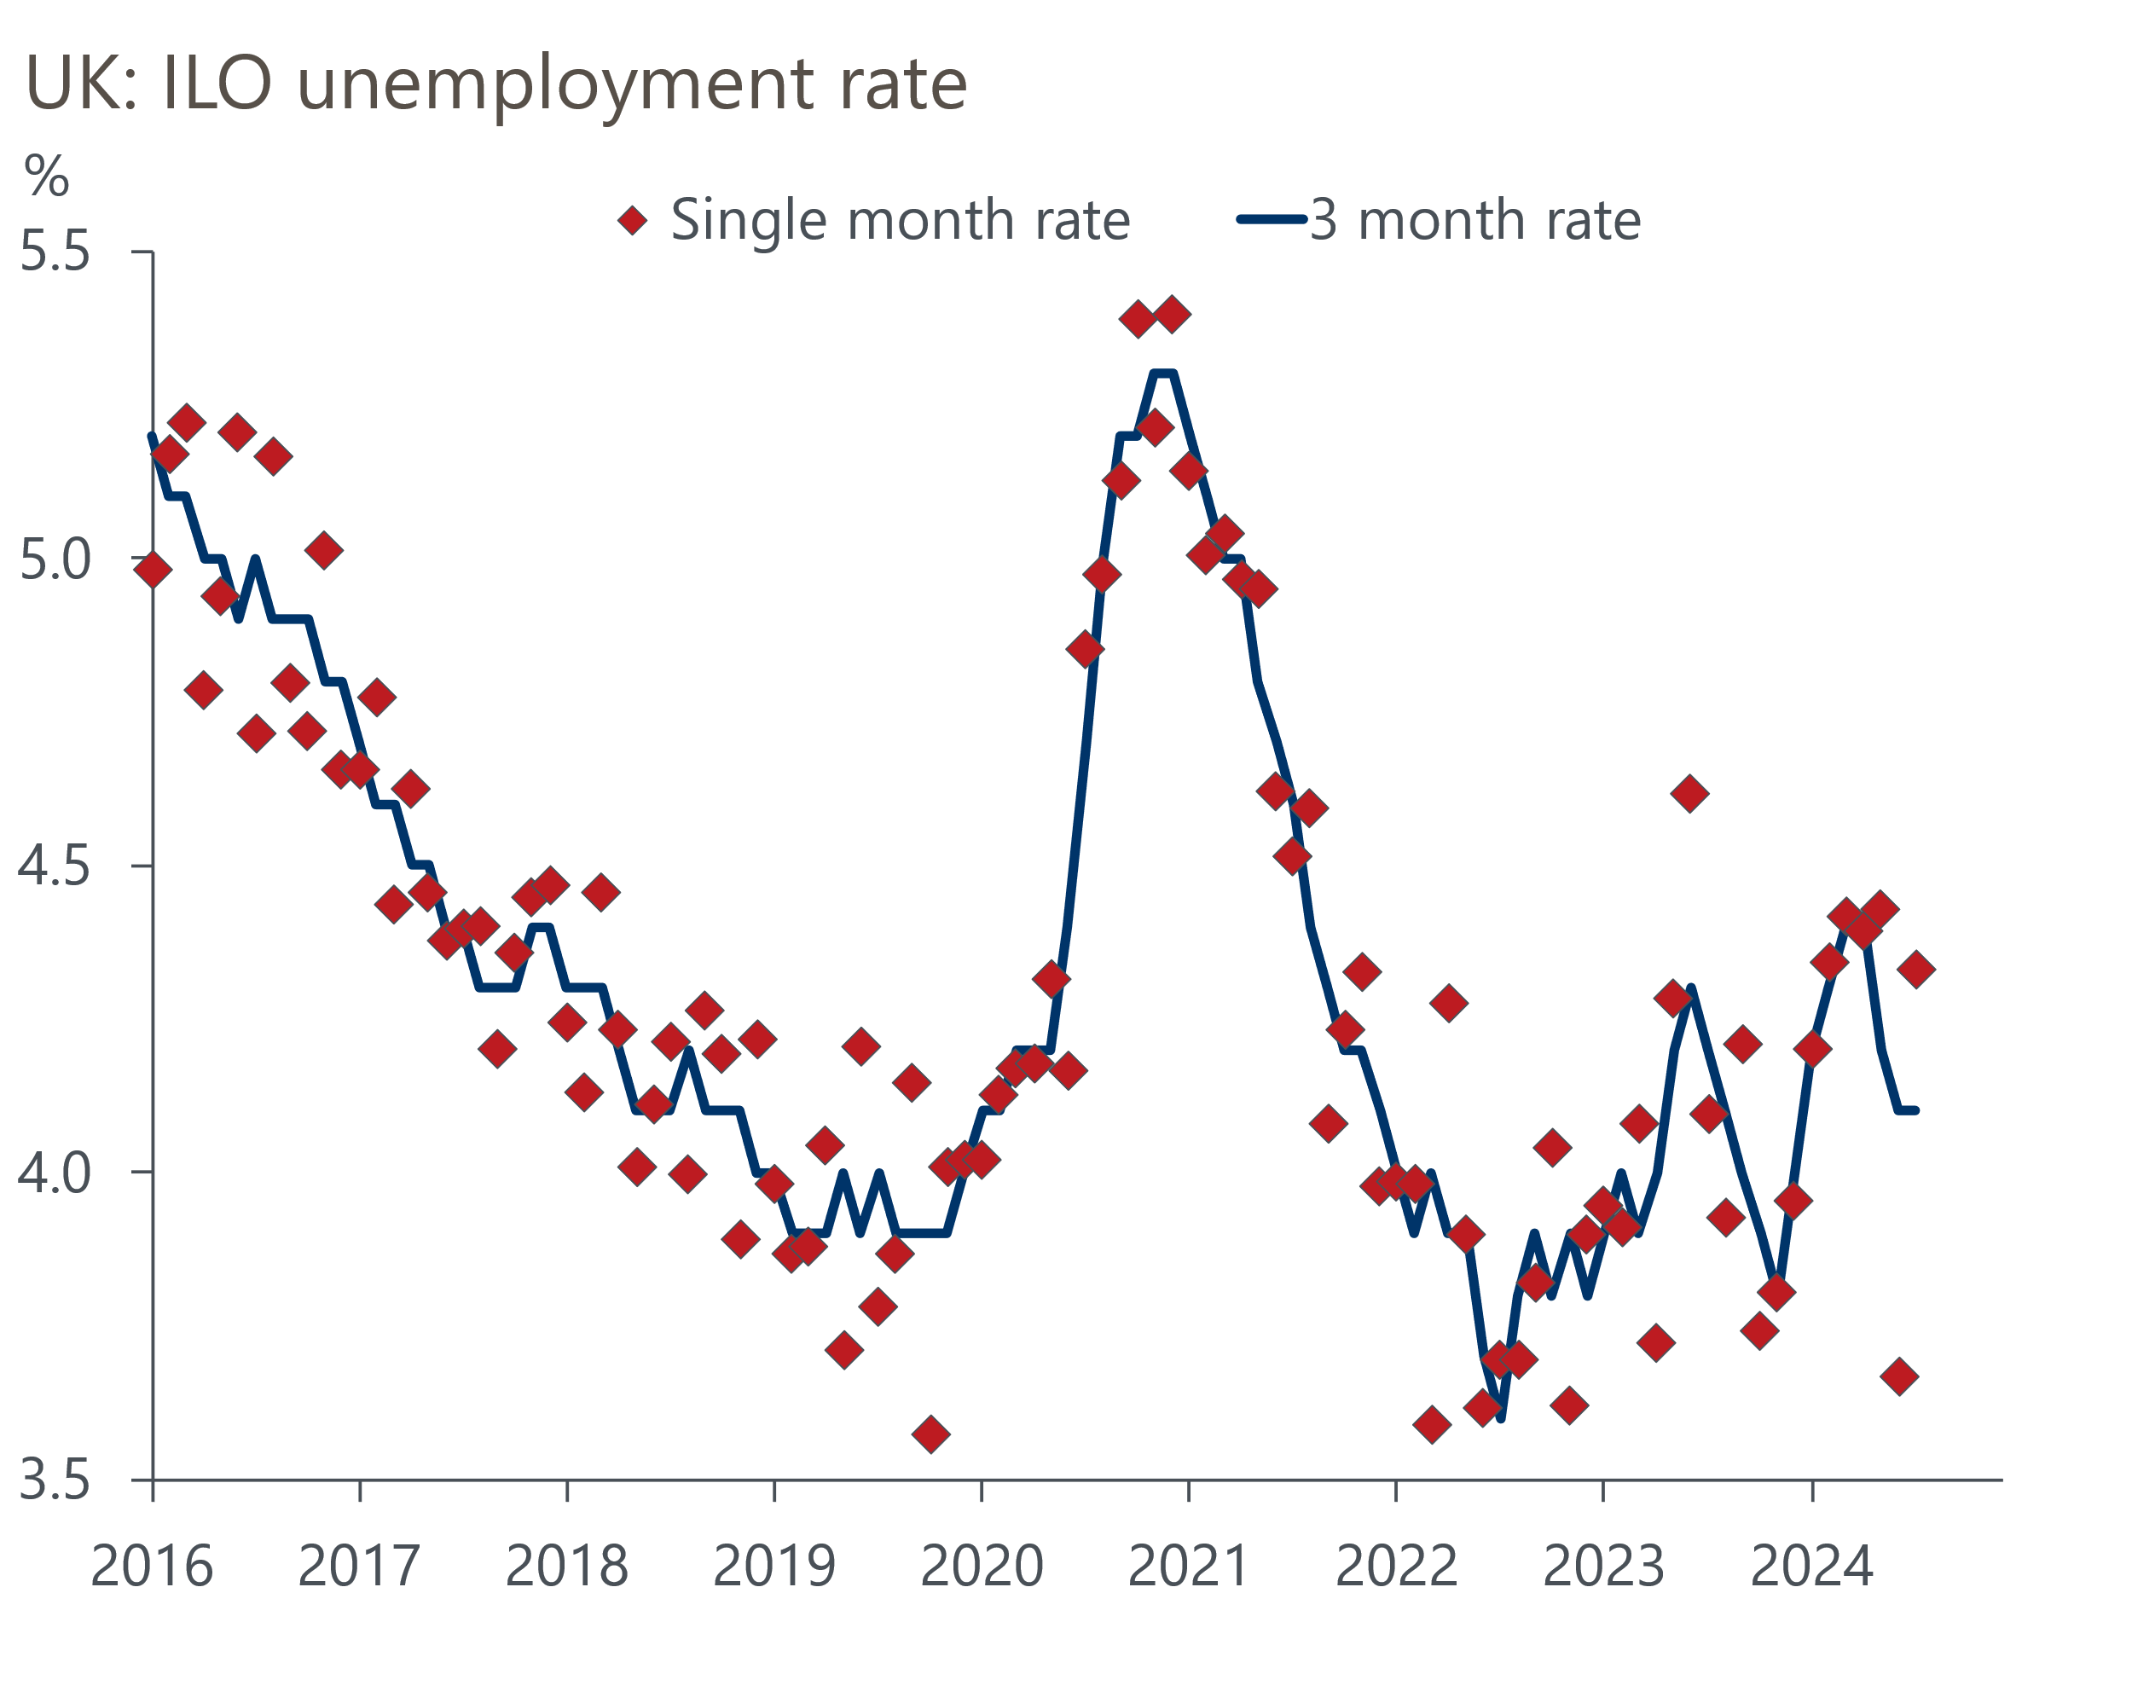
Source: Haver Analytics
To be fair to the ONS, it has been candid about the unreliability of recent LFS data and has been working hard to rectify the situation. But in July it announced that methodological improvements would take at least another six months to complete. In addition, the ONS's other measure of unemployment – the claimant count – is going through a definitional change, with the Department for Work and Pensions rolling out an increase in the administrative earnings threshold for full work search conditionality. The ONS estimates that this change could add 180,000 claimants over six months, a big change in the context of normal movements. So that series is also effectively unusable right now.
This leaves us trying to piece together a story from a hotchpotch of other series. The workforce jobs measure of employment dipped in Q2, but this followed a series of very strong outturns. HMRC's count of payrolled employees fell in August and July's outturn was revised to also show a drop, having originally reported an increase. Meanwhile, vacancies continued to fall in the three months to August, albeit they remain slightly higher than the pre-pandemic level. So labour demand appears to be gradually falling. The picture for labour supply is also very uncertain, given the lack of recent data on migration flows. But we think the most likely story is that labour market conditions are continuing to gradually loosen.
On the wage front, the main measures cooled further in the three months to July, reflecting both strong base effects and cooling momentum. Headline (three-month average of the annual rate) private sector regular pay growth slipped to a 27-month low of 4.9%, well below the rates seen last summer but still some way above the 3%-3.5% pace that the Monetary Policy Committee would view as being consistent with achieving the inflation target on a sustained basis.
Given the MPC has intimated that back-to-back cuts are unlikely, and there's been nothing in the subsequent data to warrant a change of tack, it would be a major surprise if next week's meeting yielded another rate cut. Potentially more interesting is the MPC's decision on the pace of quantitative tightening over the next 12 months. Our baseline forecast is that the MPC will cut the stock of gilts held in the Asset Purchase Facility by £100bn, the same pace as last year. But, as our MPC preview sets out, there's a strong argument for increasing the pace of QT so the year-to-year profile for gilt sales is more stable.

The week ahead
Next week's main event is the Monetary Policy Committee meeting for September. The clear message from the August meeting was that back-to-back cuts were unlikely and none of the data published since then warrants a change of approach. So we expect an 8-1 vote to keep Bank Rate at 5%, with Swati Dhingra dissenting to vote for a 25bps cut.
The MPC will also set the pace of quantitative tightening over the next 12 months. We expect the MPC will reduce the stock of gilts held in the Asset Purchase Facility by £100bn, the same pace as the past year. But the high level of redemptions due this year means that the MPC might opt to increase the pace of QT by £15bn-£20bn so the year-to-year profile for gilt sales is more stable.
Though we expect CPI inflation to have held steady at 2.2% in August, there are likely to be some sizeable movements in the sub-components. Weekly data from the Department of Environment and Climate Change suggests petrol prices fell by 1.6% between July and August, having risen by nearly 4% between those months last year. But while petrol should exert a drag, we expect this to be offset by higher core inflation, largely because of the strength of base effects caused by a soft reading last year.
After a sharp fall in June, retail sales only partially recovered in July. The results from the August CBI and BRC surveys were better than in recent months but underwhelming by historical standards. We forecast a 0.1% month-on-month increase in the including fuel measure, though the extreme volatility of the data over the past year means a wide range of outcomes is possible.
Table 1: Week ahead calendar
Date | Events | Period | Measure | Unit | Previous | Forecast
Sep 18 | CPI inflation | Aug | m/m | % | -0.2 | 0.3
Sep 18 | CPI inflation | Aug | y/y | % | 2.2 | 2.2
Sep 18 | RPI inflation | Aug | m/m | % | 0.1 | 0.5
Sep 18 | RPI inflation | Aug | y/y | % | 3.6 | 3.4
Sep 18 | Producer input prices | Aug | m/m | % | -0.1 | 0.2
Sep 18 | Producer input prices | Aug | y/y | % | 0.4 | -0.4
Sep 18 | Producer output prices | Aug | m/m | % | 0.0 | 0.1
Sep 18 | Producer output prices | Aug | y/y | % | 0.8 | 0.6
Sep 18 | Land Registry house prices | Jul | y/y | % | 2.7 | 2.8
Sep 19 | BoE Bank Rate decision | Sep | Bank Rate | % | 5.00 | 5.00
Sep 19 | BoE QT decision | Sep | APF reduction | bn | 100 | 100
Sep 20 | Retail sales inc fuel | Aug | m/m | % | 0.5 | 0.1
Sep 20 | Retail sales inc fuel | Aug | y/y | % | 1.4 | 1.0
Sep 20 | Public finances | Aug | PSNB ex | £bn | 3.1 | 12.5
Source: Oxford Economics

Key forecasts
Table 2: UK forecast overview
(Annual percentage changes unless specified)
 | 2022 | 2023 | 2024 | 2025 | 2026 | 2027
GDP | 4.3 | 0.1 | 1.1 | 1.7 | 1.8 | 1.7
Private consumption | 4.8 | 0.2 | 0.6 | 2.1 | 2.0 | 1.6
Fixed investment | 8.0 | 2.2 | 0.3 | 0.9 | 2.5 | 2.1
Government consumption | 2.3 | 0.5 | 2.7 | 2.8 | 1.6 | 1.5
Exports of goods and services | 9.0 | -0.5 | -1.1 | 2.1 | 2.0 | 1.7
Imports of goods and services | 14.6 | -1.5 | 0.8 | 2.5 | 2.6 | 1.9
Industrial Production | -3.5 | -0.4 | -0.1 | 0.8 | 1.5 | 1.1
Consumer prices | 9.1 | 7.3 | 2.6 | 2.6 | 2.2 | 2.1
Unemployment rate (%) | 3.9 | 4.0 | 4.3 | 4.3 | 4.1 | 3.9
Current a/c balance (% of GDP) | -3.1 | -3.3 | -3.6 | -3.2 | -3.2 | -3.2
Government balance (% of GDP) | 4.4 | 5.0 | 4.0 | 3.2 | 2.5 | 1.7
Cen. bank policy rate (%, EOP) | 3.50 | 5.25 | 4.75 | 3.75 | 2.75 | 2.00
10yr govt. bond yield (%, EOP) | 3.67 | 3.54 | 3.93 | 3.67 | 3.24 | 2.85
Exchange rate (US$ per £, EOP) | 1.20 | 1.27 | 1.29 | 1.30 | 1.31 | 1.33
Exchange rate (euro per £, EOP) | 1.13 | 1.15 | 1.19 | 1.19 | 1.18 | 1.17
Source: Oxford Economics
Table 3: Quarterly forecasts for the UK
 | 2024 |  |  |  | 2025
 | Q1 | Q2 | Q3 | Q4 | Q1 | Q2 | Q3 | Q4
GDP (% year) | 0.3 | 0.9 | 1.3 | 2.1 | 1.8 | 1.6 | 1.7 | 1.7
CPI inflation (% year) | 3.5 | 2.1 | 2.1 | 2.5 | 2.7 | 2.5 | 2.7 | 2.5
Bank Rate (%, EOP) | 5.25 | 5.25 | 5.00 | 4.75 | 4.50 | 4.25 | 4.00 | 3.75
10yr gilt yield (%, EOP) | 3.95 | 4.17 | 3.95 | 3.93 | 3.87 | 3.80 | 3.74 | 3.67
US$ per £ (EOP) | 1.26 | 1.26 | 1.30 | 1.29 | 1.29 | 1.29 | 1.30 | 1.30
Euro per £ (EOP) | 1.17 | 1.18 | 1.19 | 1.19 | 1.19 | 1.19 | 1.19 | 1.19
Source: Oxford Economics

Latest Country Economic Forecast:
September 13, 2024

Recent publications

Data Insights
GDP flatlined for the second consecutive month in July
Labour market data consistent with gradual pace of rate cuts
Stronger services PMI suggests GDP growth will remain solid
Stronger domestic market drove up August's manufacturing PMI
Rate cuts should drive a gradual recovery in mortgage demand

Research Briefings
MPC preview – Pace of gilts sell-off is the key decision
MPC easing - how far and how fast?
Growth may slow, but the consensus looks too weak
Rate-cut cycle kicks off but it’s unlikely to be sequential
Reeves review lays the ground for October tax rises

Contacts

Oxford Economics' UK team
- Andrew Goodwin - Chief UK Economist - agoodwin@oxfordeconomics.com
- Edward Allenby - UK Economist - eallenby@oxfordeconomics.com

